DES-01: System and Pipeline Specifications
System: UPHSL Credential Tracker (Online Academic Credential Request, Tracking and Monitoring)
Institution: University of Perpetual Help System, Office of the Registrar
Date: October 11, 2026

1. Overview
The UPHSL Credential Tracker is a web system that records every academic credential request as it moves from office to office. Students always know where their document is, department staff see what is waiting for their signature, and the Office of the Registrar controls and monitors the flow.
The system is a digital ledger. The paper credential is never sent digitally; the system records each request, every hand-off and signature between offices, and the student's proof of payment for paid credentials.
Note on the machine-learning stages. The system does not use a machine-learning model. In this document the "model / system processing" stage is a rule-based workflow engine (RequestWorkflow) that routes each request through its signing offices and allows only valid status changes. The "API / inference" stage is the server layer that applies those rules and computes derived values such as due dates and overdue flags.
Table 1. Technology stack
Layer | Technology
Web framework | Laravel 12 (PHP 8.4)
User interface | Livewire 4, Blade templates, Tailwind CSS 4, Flux UI components
Database | MySQL 8.4: uphsl_credential_tracker (production) and uphsl_credential_tracker_staging (staging)
Environments | Two: staging (development, demos, tests) and production (real use)
File storage | Cloudflare R2 private bucket for payment receipts (folders staging/ and production/)
Email | Gmail SMTP in production; staging writes emails to a log file
Background processing | Laravel queue (database driver) for notifications and email
Quality assurance | Pest automated tests (151 passing), PHPStan static analysis, Laravel Pint

2. System Architecture
Figure 1 shows the components of the system. Three kinds of users work through a web browser. All requests go to one Laravel application, which is organised in four layers and uses one MySQL database.
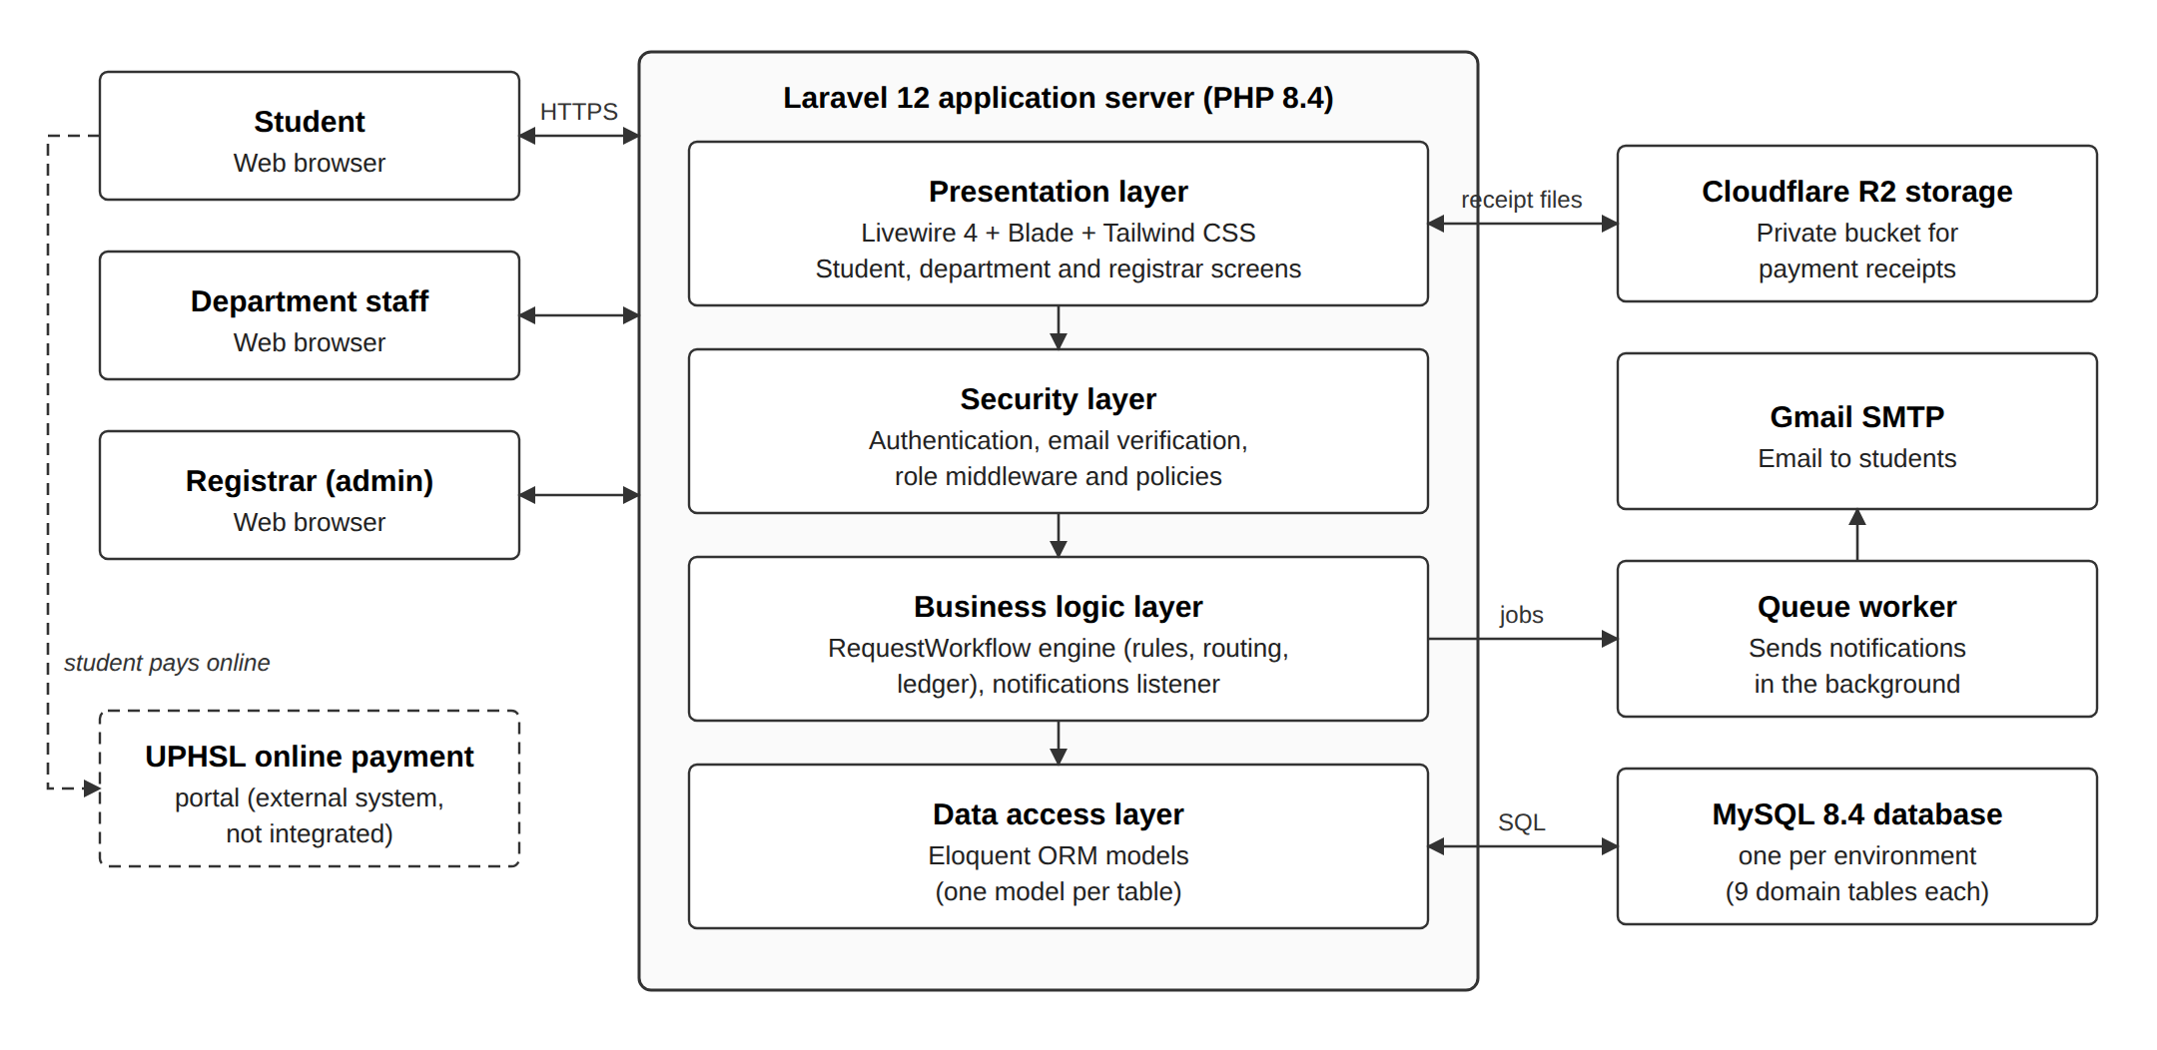
Figure 1. System architecture diagram
Table 2. Architecture components
Component | Responsibility
Users (web browser) | Students request credentials and track them; department staff sign or hold requests; the registrar reviews, routes, releases and configures the system.
Presentation layer | Livewire screens for each role: request form, tracking page, signature queue, registrar dashboard and administration pages.
Security layer | Login, email verification, role middleware (student, department, registrar) and policies that decide who may view or act on each request.
Business logic layer | The RequestWorkflow engine: the only place where request and step statuses change. It locks the record, checks the transition, saves it and writes the ledger. A listener then sends notifications.
Data access layer | Eloquent ORM models, one per table, mapping PHP objects to MySQL rows.
MySQL 8.4 database | One database per environment (staging, production). Stores users, departments, credential types, workflows, requests, steps, payment proofs, the ledger and notifications.
Cloudflare R2 storage | Private bucket holding uploaded receipts, one folder per environment. Files are served through the app only to the owner and registrar accounts.
Queue worker and Gmail SMTP | Send in-app and email notifications in the background so that user actions stay fast.
UPHSL online payment portal | External system where students pay. It is linked from the request page but not integrated; the student uploads the receipt instead.

3. Data Pipeline
Figure 2 shows how data moves from its source to the final output in nine stages. Stage 6 is highlighted because it takes the place of a machine-learning model.
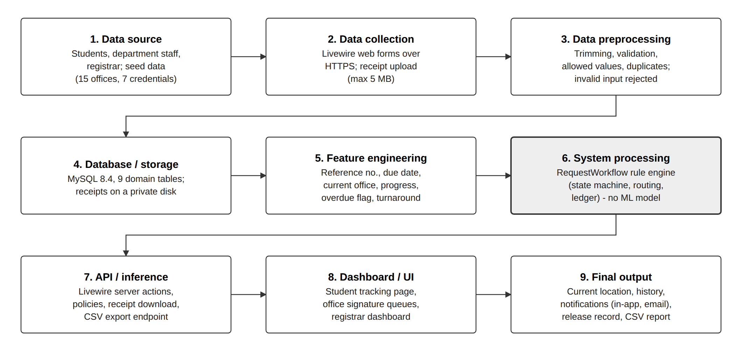
Figure 2. Data pipeline diagram

4. Pipeline Stage Specifications
Table 3. Specification of each pipeline stage
# | Stage | What happens in this system | Component / technology
1 | Data source | Students submit request details and a receipt image. Department staff sign or hold. The registrar approves and configures departments, credential types and workflows. Seed data adds 15 departments and 7 credential types. | Web browser
2 | Data collection | Forms are submitted over HTTPS. Receipts are uploaded as JPG, PNG, WebP or PDF, up to 5 MB. | Livewire forms, file upload
3 | Data preprocessing | Text is trimmed and checked: required fields, data types, ranges, formats, allowed values and duplicates. Invalid input is rejected with a message (see DES-04). | Laravel validation, form objects
4 | Database / storage | Records are stored in 9 domain tables. Receipt files are stored on a private disk. | MySQL 8.4, Eloquent ORM
5 | Feature engineering | Derived values are computed: reference number, fee snapshot, resolved college step, due date (weekdays only), overdue flag, current office, progress, turnaround time and workload per office (see DES-03). | Workflow engine, SQL
6 | System processing | A rule-based engine routes each request through its signing offices one at a time and allows only valid status changes. Every change is appended to the ledger. No machine-learning model is used. | RequestWorkflow service
7 | API / inference | Server actions apply the rules and return the result to the page. Policies check who may view or act. Endpoints also serve receipt downloads and the CSV export. | Livewire actions, routes, policies
8 | Dashboard / UI | Students see "Where is my document?" and a tracking history. Offices see a signature queue. The registrar sees status counts, overdue requests and where requests are waiting. | Blade, Livewire, Tailwind CSS
9 | Final output | The document's current location, its full history, in-app and email notifications, the release record and CSV reports. | Notifications, queue, CSV

5. Explanation of the Flow
A Transcript of Records (TOR) request from a College of Computer Studies alumnus shows the whole flow.
- Data source and collection. The student fills in the request form: credential, number of copies, purpose, student number, college, program, student status and last school year attended.
- Preprocessing. The server trims and validates every field. A wrong school-year format or an inactive college is rejected before anything is saved.
- Storage. The request is saved with a reference number such as CR-2026-000001 and the status "Awaiting payment", because the TOR requires payment.
- Payment. The student pays on the UPHSL online payment portal and uploads the receipt. The file goes to private storage and the status becomes "Payment under review".
- System processing. The registrar accepts the payment. The workflow engine copies the TOR signing order into the request (Library, Cashier / Finance Office, College of Computer Studies, Office of the Registrar) and sets the due date.
- Feature engineering and API. Each signature moves the request to the next office. The system recomputes the current office, progress, the overdue flag and office workloads.
- Dashboard and final output. The student's page shows where the document is and every hand-off. The next office is notified. When the last office signs, the student is told the document is ready for release, and the registrar marks it released when it is claimed.
Each status change in this flow is written to the append-only ledger (table request_events). The tracking history, notifications and reports are built from that ledger.

